**INVERSE TRIGONOMETRIC FUNCTIONS**

**(a.k.a. arcsin, arccos and arctan)**

If we restrict the function f(x) = sinx so that its domain is the closed interval , this function has an inverse. This inverse sine function is denoted by f-1(x) = sin-1x or arcsinx. For example, if sin 30o = 0.5, the inverse function would be to find the angle that has a sine of 0.5, sin-1 (0.5) = 30o

y = sin-1x = arcsinx if and only if (iff) siny = x for  and .

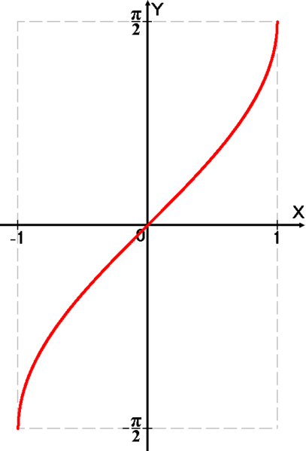

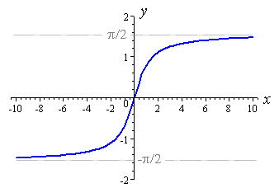

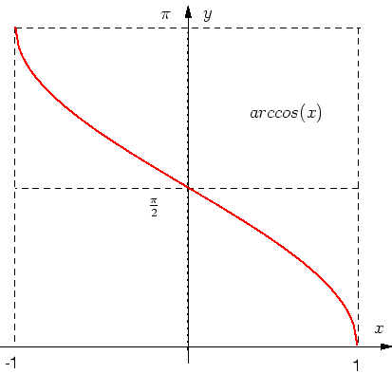

y = arcsinx y = arccosx y = arctanx

**WARNING**: the -1 appearing in the notation f-1(x) = sin-1x is **NOT** an exponent. It denotes the inverse function. It does **NOT** mean (sin x)-1 =  (which is the reciprocal of sin x and is equal to csc x).

The restricted cosine function is the function g(x) = cos x whose domain is the closed interval . The inverse cosine function is denoted by g-1(x) = cos-1 x or arccos x. Thus, y = cos-1x **iff** cos y = x for and .

Examples: cos-1() =  since cos  = 

Sin -1(-1) =  since sin= -1